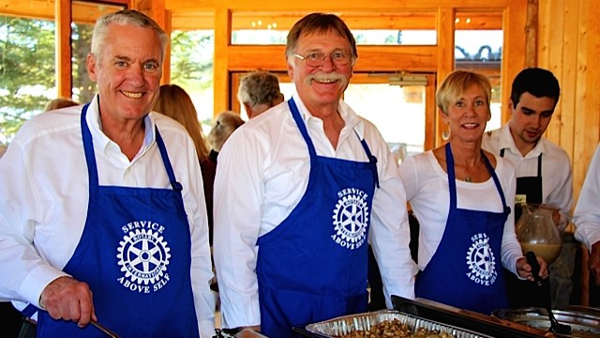

Rotary hosts second annual Thanksgiving lunch for mountain area seniors
Posted by rotary on November 25, 2015 in Evergreen, Jefferson County Front, Jefferson County Government | 8 Views | Leave a response
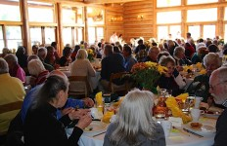

On Thursday November 19th, The Evergreen and Foothills Rotary Clubs treated 180 local seniors to a full traditional Thanksgiving lunch at the Lake House.
The day before, Pam McQuin from the Seniors Resource Center (SRC) supervised Rotary Club members as they peeled 60lbs of potatoes and 15lbs of carrots, onions and celery, and filled 200 party bags with homemade cookies, folded 200 napkins and washed and dried hundreds of glasses and coffee cups.
Some 40 plus volunteers from Rotary had stepped up to roast 13 turkeys, bake more than 600 cookies and 200 rolls and muffins, and make a myriad of delicious desserts; pumpkin pies, scones, apple and custard pies and date cakes.
Tasty volunteer-made hors d’ oeuvres were served to seated guests, and they were then summoned to the Octagon Room where Rotary volunteers served a menu of freshly- roasted turkey, gravy, mashed potatoes, cranberry stuffing and green beans. Warm rolls, butter, cranberry relish, and relish plates were placed on the guest tables.
The Lake House literally sparkled with Annette Bradley’s decorations as Bob Bradley, president of the Evergreen Rotary Club welcomed the senior guests and offered Grace before lunch. Ann Moore, an Evergreen Rotary member and Evergreen Chorale member gathered other Chorale members who were also Rotarians, and entertained the guests with songs of the seasons, and encouraged guests to sing along.
As the event ended, many guests were still deep into conversations with their table mates, many of whom they had just met.
The 2015 organizing committee was comprised of Rotary members, Barb Scripps, Nancy Grant, Mimi Nelson, Warren Rose and also Lori Joslin, Seniors Resource Center Executive Director.
Once again, the Evergreen and Foothills Rotary Clubs were proud to be of service to the local community and continue Rotary International’s rich tradition of ‘Service Above Self’.
Contact: Mimi Nelson: mimi80439@aol.com
About Rotary
Rotary brings together a global network of volunteer leaders dedicated to tackling the world’s most pressing humanitarian challenges. Rotary connects 1.2 million members of more than 34,000 Rotary clubs in over 200 countries and geographical areas. Their work impacts lives at both the local and international levels, from helping families in need in their own communities to working toward a polio-free world. For more information, visit Evergreen Rotary
Posted in Evergreen, Jefferson County Front, Jefferson County Government

