Member Business Directory

March 2019

Business/Consulting
Gary Ervick | ERVick Consulting Group, LLC
PO Box 3425, Evergreen, CO 80437
We help clients develop and manage strategic, cultural, and structural changes within their organizations. We help them determine where they want to go (results they want to achieve) and how they’re going to get there (action plans to make that happen).
www.ervickconsulting.com |  | gary@ervickconsulting.com | 303-549-5631

Business/Consulting
Alan Rubin | Useful Knowledge, LLC
28825 Summit Ranch Dr. Golden, Colorado 80401
Sales process analysis, customized sales training, sales coaching, sales/marketing alignment and sales effectiveness analytics
www.useful-knowledge.com |  | alan@useful-knowledge.com | 303.725.8750

Business/Consulting
Robert Wallace | Wallace Health Strategies, LLC
2852 Bergen Hill Drive, Evergreen CO 80439
Strategic planning, facilitation services, rural health expertise, general health care consulting, interim C Suite services
 |  | Rwall5@comcast.net | 303-548-2375

Business/Consulting
Janee Meyers | JEM Consulting
4239 Scenic Village Drive, Evergreen CO 80439
Assist families and older adults to select and arrange quality services, including at home programs and senior living options. Operations consulting to companies in the senior living and senior services industry.
 |  | Jane.e.weinberger@gmail.com | 303-909-8229

Career Coaching
Nathan Teegarden | Your True Calling
2922 Evergreen Parkway, Suite 207, Evergreen CO 80439
Nathan Teegarden is a fully integrated Career and Life Coaching Service for Adults and Students.
www.YourTrueCalling.com |  | Nathan@YourTrueCalling.com | 720-279-2390

Catering
Mimi Nelson | In Good Taste Catering
29691 Fairway Drive, Evergreen, CO 80439
 |  | mimi80439@aol.com | 303-674-3192

Computer Programming
Todd Landrum | Paladin Programming
31375 Burn Ln, Evergreen, CO 80439
Create custom database software for a wide variety of industries.

www.paladinpgm.com |  | todd@paladinpgm.com | 303-263-4333

Cosmetics
Gretchen MacArthur | Independent Sr. Sales Director  Mary Kay Cosmetics, Inc.
6997 Timbers Drive, Evergreen, CO 80439
I offer complimentary makeovers and a career opportunity to women.
www.marykay.com/gmacarthur |  | gretchen_macarthur@yahoo.com | 303-526-0446

Design Services/Retail
Kay D’Evelyn  La Montagne | The Evergreen Design Center
27965 Meadow Dr., Evergreen, CO 80439
One Historical Location, 9 Exceptional Design Stores offering Furniture, Kitchen Cabinetry, Hand Knotted Rugs, Hardwood Flooring, Framing, Home Accessories, and Interior Design Services.
evergreendesigncenter.com |  | kay@mountainhome.net | 303-746-7777

Drone Services
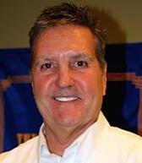  Chuck Adams | 1 UP Aerial Drone Services, Inc.
23765 Currant Dr., Golden, CO 80401
Whether performing simple aerial drone photography, construction surveys, inspecting pipelines, real estate drone photography, aiding in surveillance or helping farmers enhance yields, drones are developing into powerful business tools. WE SELL DRONES, WE PROVIDE DRONE SERVICES, WE OFFER TRAINING, DEVELOPMENT, & CONSULTATION
WWW.1UPDrones.com |  | chucka@1updrones.com | 720 476 4101

Education
Carolyn Alexander Ret. | Jefferson County Schools
Jeffco Public Schools
Carolyn is a retired teacher.
 |  | C.R.Alexander@comcast.net | 303-674-6372

Education
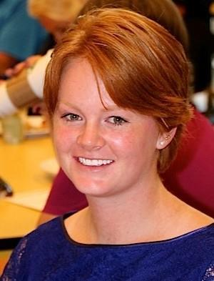  Lauren Davis | Critical Knowledge Initiative
8729 S Turkey Creek Rd, Morrison, CO 80465
To arm young adults with tools and knowledge imperative to personal, professional, and financial success

www.criticalknowledgeinitiative.com |  | Cki.lauren@gmail.com | 303-435-2025

Faith
Mendhi Audlin | Unity of the Foothills
Office: 28577 Buffalo Park Road, Suite 120,
Meetings: Buchanan Rec Center in Evergreen
Our mission is to "transform lives through the power of Love." Our Sunday services are at 11 am at the Buchanan Rec Center with small groups that meet throughout the week to discuss topics related to spiritual growth and personal transformation.
http://www.unityofthefoothills.com |  | unityofthefoothills@gmail.com | 303-993-2560

Financial Services
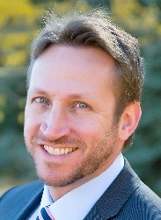  Kris Fisher | Kachkovsky & Fisher
30752 Southview Drive, Suite 290, Evergreen, CO 80439
As an independent fee-only Registered Investment Advisor, we are held to the highest standard of responsibility to our clients by law. As fiduciaries and CFPs, we act as long-term stewards of client assets through comprehensive financial planning and investment management.
www.kachkovskyandfisher.com |  | kris@kachkovskyandfisher.com | 303-674-9711

Financial Investigation
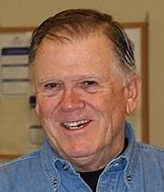  Doug Griffin Ret. | CPA, CFE
P.O. Box 17953, Golden, CO
Formerly Manager of Investigations of Labor Unions in the Rocky Mt. States, USDOL.
Formerly head of U.S. Sales, Synera Software and Analytics
Formerly VP and Manager of Business Investigative Services, Bank of America
 |  | dgriffin@ix.netcom.com | 303-888-6717

Financial Services
Ron Larson (Ret.) | Brenton Bank
Cedar Rapids, Iowa
Retired as Bank President in 2000 when sold to Wells Fargo. Year 2000 to 2015 Bank Owner/ Board member. Banking consultant/teacher since 2000 in Viet Nam, Ghana, Serbia, Burkina Faso, Tunisia.
 |  | ronlarson2225@gmail.com | 319-360-3849

Financial Services
Anna Harry | Transamerica Financial Advisors
3000 Youngfield, Suite 261, Lakewood, CO 80215
I create retirement plans by simultaneously maximizing growth, minimizing taxes, and protecting loved ones using financial vehicles of Variable Universal Life or Indexed Universal Life insurance, and I roll 401k or Pensions into the best Variable Annuities on the market. Referral, not fee-based.
www.annaharry.com |  | anna.harry@tfaconnect.com | Phone: 919-244-6856  Fax: 303- 235-022

Financial Services
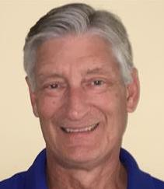  Curt Harris (Ret.) | FirstBank
30770 Stagecoach Blvd., Evergreen, CO, El Rancho and over 100 other locations in Colorado
FirstBank is a locally-owned bank that began in Lakewood in 1963. It has grown to the second largest bank in Colorado by offering superior customer service and being a part of the local community.
www.efirstbank.com |  | Charris999@aol.com | 303-237-5000

Financial Services
Dave Rommelmann | Prime Financial Services, Inc.
30752 Southview Dr., Suite 280, Evergreen, Co 80439
Financial Advisor-Securities offered through Raymond James Financial, Inc., Member FINRA/SIPC
www.raymondjames.com/PRIMEFinancialServices |  | david.rommelmann@raymondjames.com | Phone: (303) 586-9889  Direct: (303)586-9890  Cell: (303 522-1191  Fax: (303) 586-9898

Financial Services
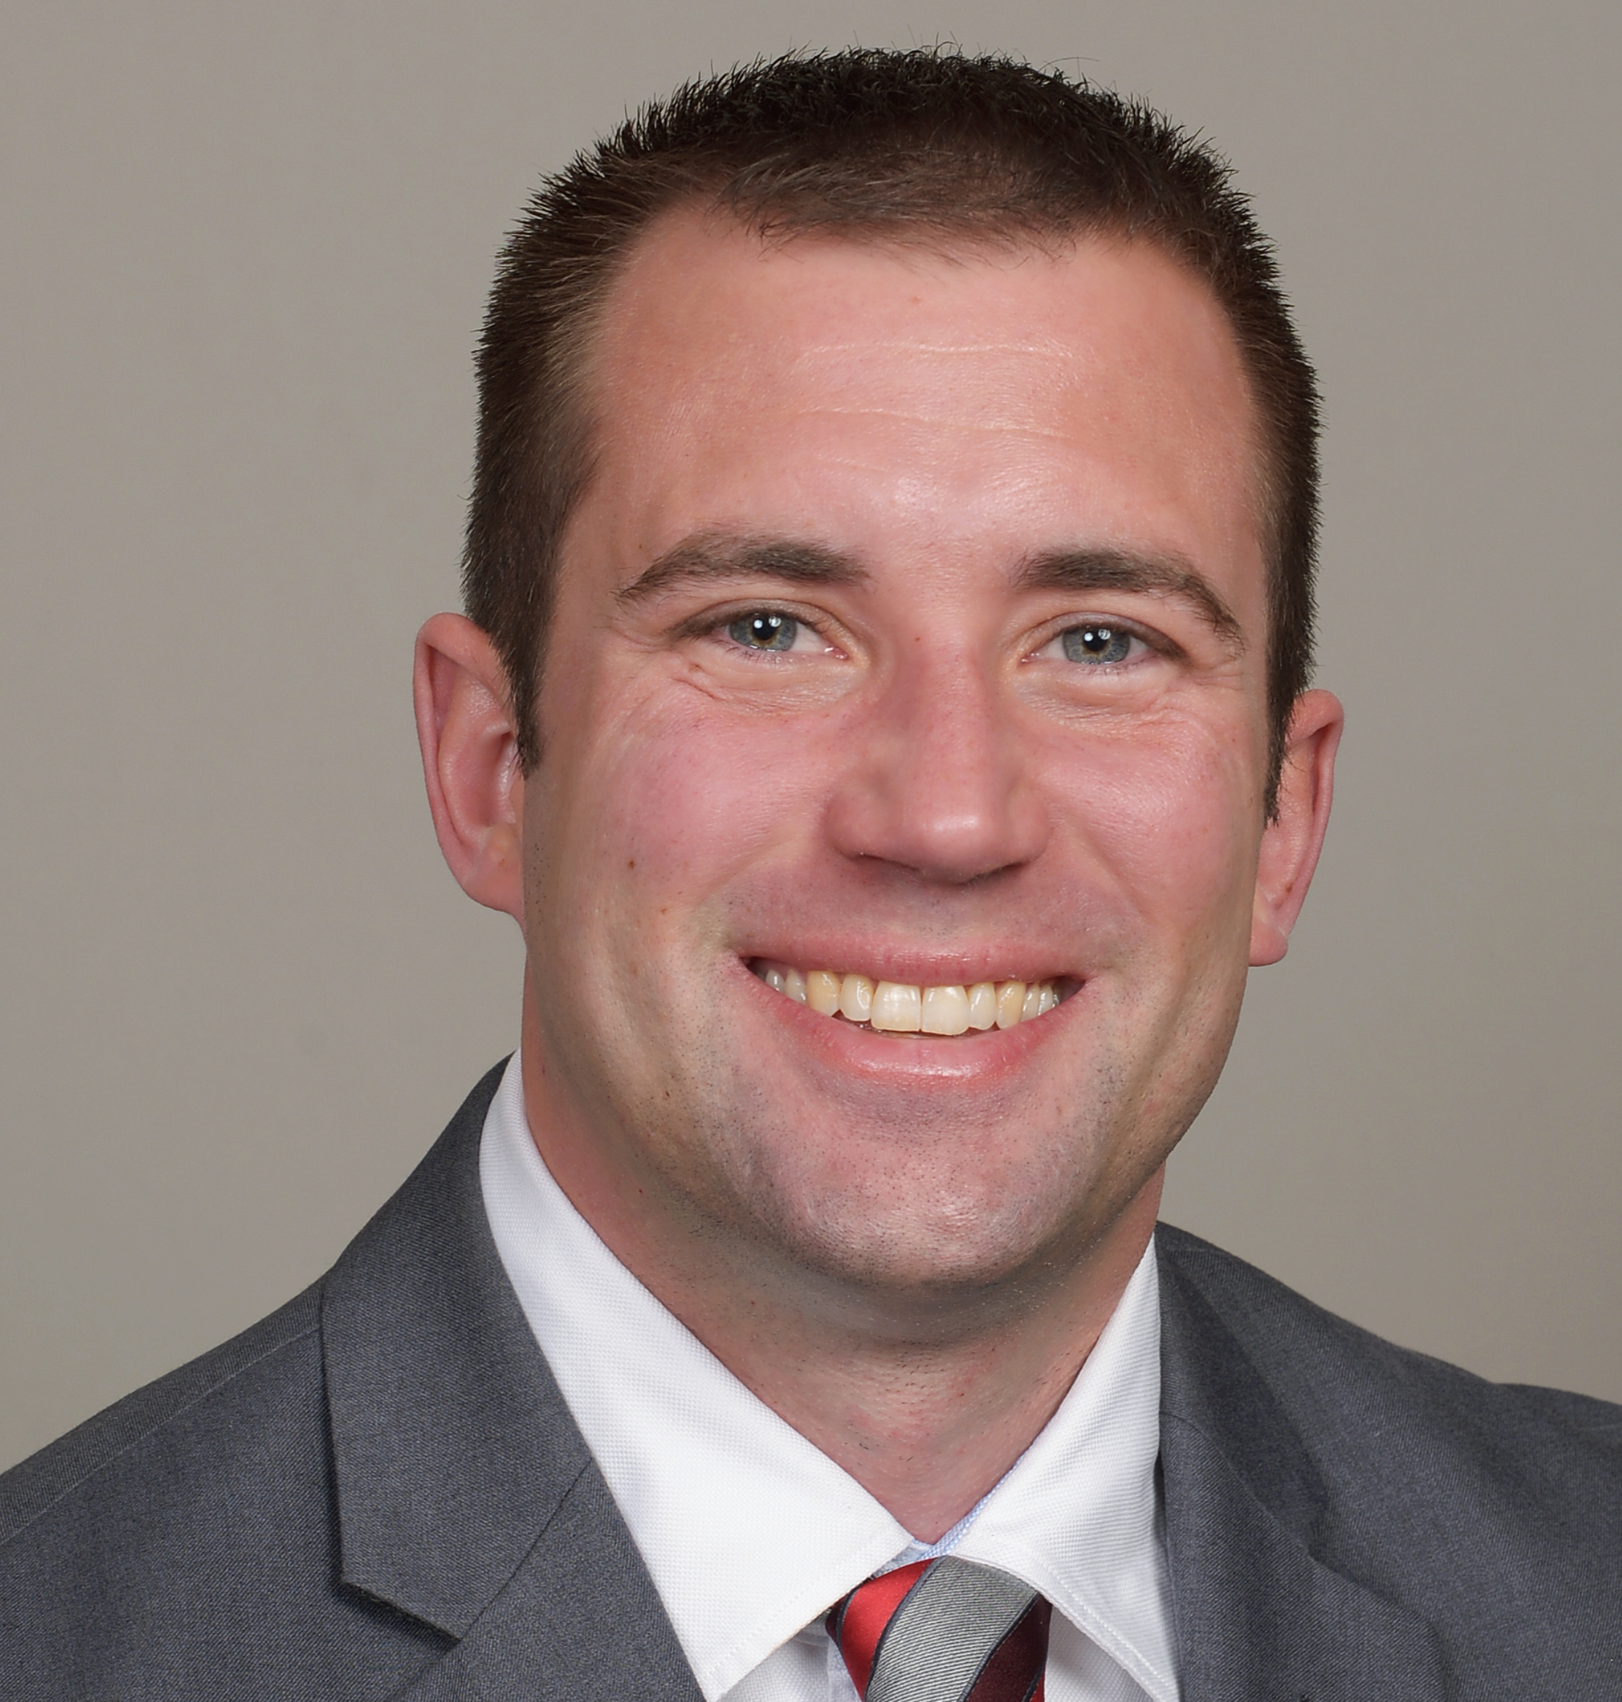  Davis Linden | Edward Jones
25918 Genesee Trail Rd, Suite #130 Golden, Co 80401
I am a financial advisor with Edward Jones and have been in the industry since August of 2011. I am proud to partner with my clients to develop a consistent and repeatable process to reach their financial goals.
www.edwardjones.com |  | davis.linden@edwardjones.com | Phone: 303-526-0133  Fax: 888-281-6721

Financial Services
Barb Scripps | Scripps, Taylor & Associates, P.C., CPAs
1202 Bergen Parkway Ste. 208, Evergreen, CO 80439
Tax planning for business acquisitions, mergers and sales. Consultation for business start-up and operation. International taxation consulting and planning. Tax and financial planning for individuals. Tax return preparation for businesses, individuals, estates and trusts.
www.scrippstaylorcpas.com |  | office@scrippstaylorcpas.com | Phone: 303-670-8930  Fax: 303-674-4205

Financial Services
John Seevers | Valentine Seevers & Associates, PC
3781 Evergreen Parkway, Evergreen, CO 80439
We are a CPA firm providing income tax consulting and preparation services to clients of all sizes and complexity. We also provide retirement planning and consulting services and we offer payroll outsourcing services along with full service accounting outsourcing.
www.vsaacpa.com |  | jseevers@vsaacpa.com | Office: 303-674-5561  Fax: 303-459-5454

Financial Services
Adam Bjelica | Felde CPA Group, LLC
1202 Bergen Parkway Suite 306, Evergreen, CO 80439
Felde CPA Group, LLC is a tax and accounting firm with expertise to provide solutions to help you achieve your financial goals. We believe that our team of caring and highly qualified professionals can not only meet your needs but deliver exceptional results that will exceed your expectations.
www.feldecpa.com |  | info@feldecpa.com | Office: 303-674-9477  Fax: 303-253-8657

Financial Services
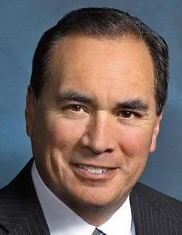  Kevin F. McGuire | Kevin F. McGuire MBA Financial Advisor
3000 Youngfield St., Suite 261 Lakewood, CO. 80215
Financial Services, Insurance, Securities, Registered Represenative
https://kevinmcguire.wfgopportunity.com |  | kevin.mcguire@tfaconnect.com | Office: 303-235-0223  Cell: 303-775-1768  Fax: 303-235-0224

Marketing, Branding
Laurie Romberg | Romberg Designs Plus
2357 Hearth Drive, Evergreen, CO 80439
Romberg Designs Plus is pleased to serve small businesses, non-profits and events to help them with their branding, marketing, and promotional needs.

www.rombergdesignsplus.com |  | laurie@rombergdesignsplus.com | 303-679-1762

Health and Fitness
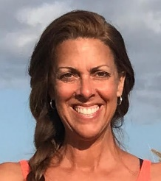  Kelly Gant | Kelly Gant Yoga and Pilates
31480 Brookline Road, Evergreen, CO 80439
Kelly Gant is a certified master trainer in BASI Pilates and a certified yoga instructor with over 13 years of teaching experience. Kelly teaches pilates, free Veterans Yoga, Yin Yoga, Adaptive Yoga for Disabilities, iRest ™Yoga Nidra & Yoga for Resilience.
www.kellygant.com |  | kelly@kellygant.com | 317-513-6998

Health and Fitness
Courtney McLauren | Evergreen Swims
29713 Troutdale Scenic Dr., Unit C-1, Evergreen, Colorado 80439
Evergreen Swims lets the water work for you not matter what stage of life you are in through: Comfort, Healing, Therapeutics, Education and Confidence. Offering learn to swim, fitness classes, special needs, gravity challenged & rehabilitating injuries
http://www.evergreenswims.com/ |  | evergreenswims@gmail.com | 720-432-5240

Health and Fitness
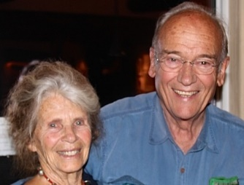  Ann & Mike Moore (Ret.) | Snugli & Air Lift Unlimited
Evergreen, CO
Ann invented the Snugli baby carrier inspired by the African mothers with whom she had worked as a Peace Corps Volunteer. Air Lift Oxygen Carrier was invented at the behest of Leslie Beauparlant, an Evergreen friend and respiratory therapist.
 | ann@annmooreco.com  mikemoore@yodlrmike.com | 303-526-1546  303-526-1549

Health and Fitness
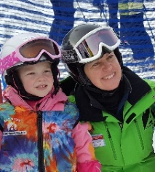  Marianne Temple | Alpine Ski Instructor
29320 Northstar Ln., Evergreen, CO 80439
Marianne is a professional ski instructor for children and adult students. Her primary ski instruction location is at Loveland Ski Area and she offers secondary locations at any Colorado Vail Resort.

www.skiloveland.com |  | mariannetemple60@gmail.com | 303-641-0692

Insurance
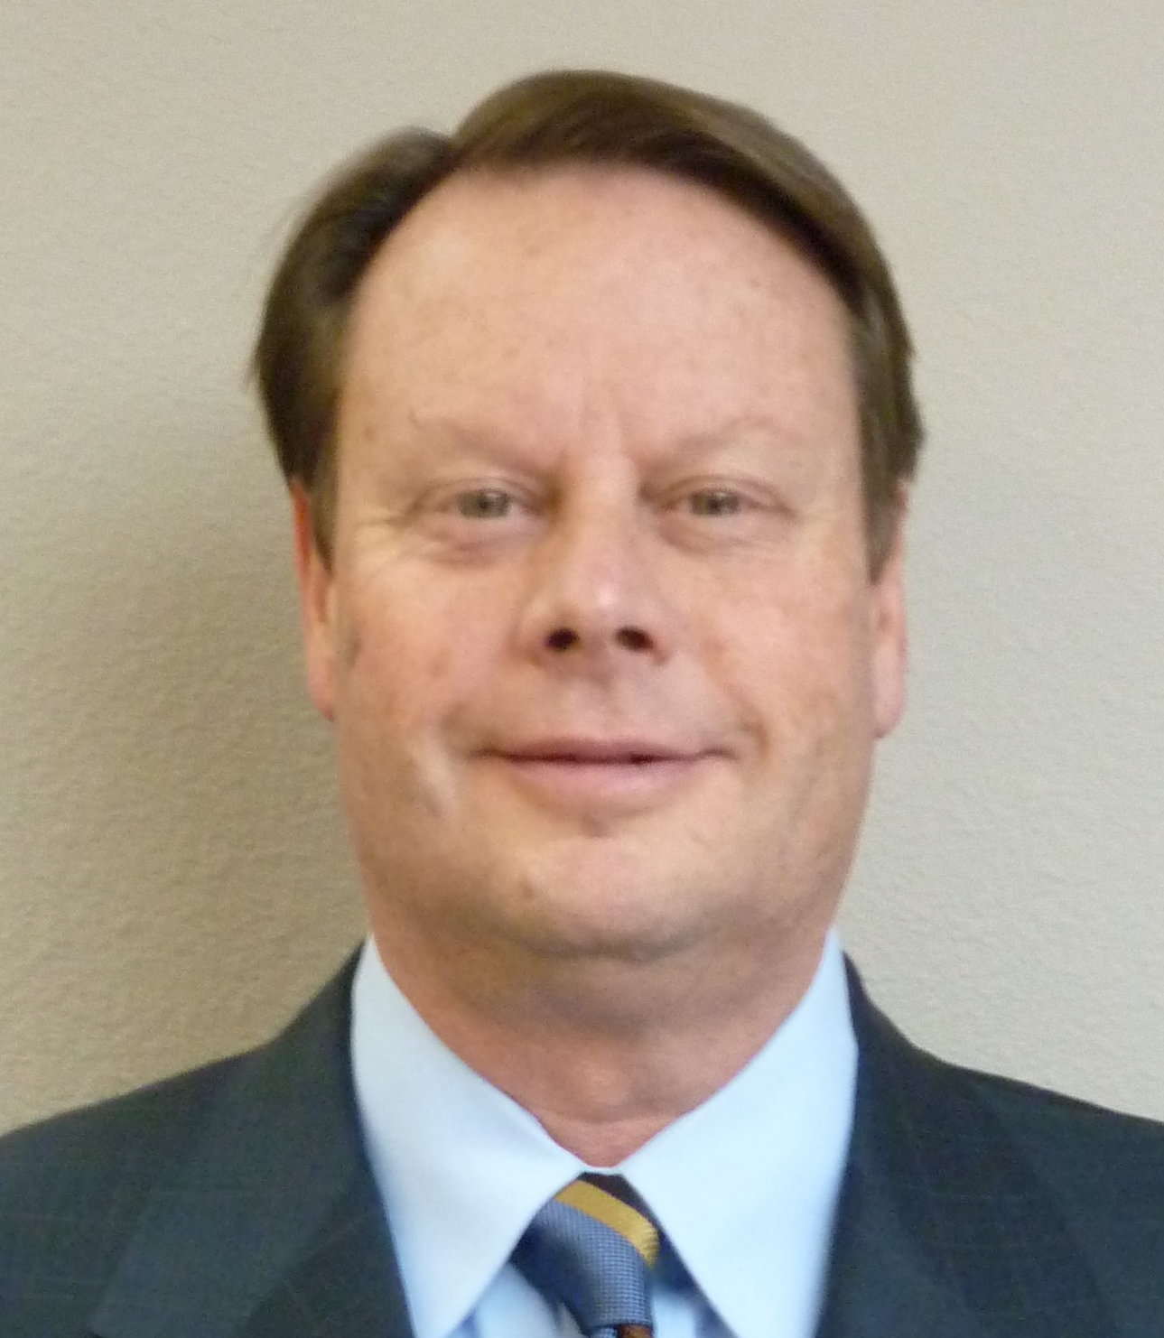  Bruce Anderson | Farmer's Insurance  Anderson Insurance Agency LLC
28000 Meadow Drive, Suite #2, Evergreen, CO 80439
Full service Farmers Insurance agency specializing in home, auto, commercial, life, specialty insurance and financial services. We are a client focused agency and pride ourselves on delivering an unmatched client service experience.

https://agents.farmers.com/co/evergreen/bruce-anderson |  | banderson2@farmersagent.com | Office: 303-674-2724  Mobile: 303-718-9966  Fax: 303-679-9956

Insurance
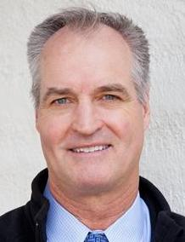  Tim Murray | State Farm  Chuck Ridings Agency
3112 Evergreen Parkway, Evergreen, CO 80439
The Chuck Ridings Agency is your local, friendly provider of insurance and financial services for: auto, home, business, life, banking, and investments.
www.chuckridings.com |  | tim@chuckridings.com | 303-674-5558 (O)  303-674-5555 (fax)

Law
Doug Turner | Douglas A. Turner, P.C. Attorneys at Law
602 Park Point Drive, Suite 240, Golden, CO 80401
Estate Planning, Probate, Real Estate, Litigation, Homeowner Associations, Business Law

www.douglasturner.com |  | dturner@douglasturner.com | 303-273-2923

Law
Rocco Dodson | Dodson and Associates, P.C.
24918 Genesee Trail Road, Golden, CO 80401
Dodson and Associates helps businesses and business people with disputes and other problems of all types, complex or more routine, whether involving contracts, insurance, real estate, construction or other issues.
www.dodsonlawfirm.net |  | rdodson@dodsonlawfirm.com | Phone: 303-526-2756  Fax: 303-526-1391

Photography
Larry Caine | Right Light Photography
25808 Sunrise Lane, Golden, CO 80401-9627
Wildlife, Nature and Fine Art photography. Worldwide coverage with Colorado specialty.
www.RLP-Photo.com |  | LECaine@comcast.net | 303-526-4257

Real Estate Services
Ron Catterson | Evergreen Commercial Group, LLC
P.O. Box 2229, Evergreen, CO 80437
Evergreen Commercial Group is a commercial real estate company that specializes in the Denver foothills … from Bailey to Blackhawk. We can help business owners with Buyer/Seller/Landlord/Tenant Representation and Property Management. We can help clients anywhere in Colorado.
www.EvergreenCommercial.net |  | ron@evergreencommercial.net | Cell: 720-205-2640 Office: 303-838-2000 x107

Real Estate Services
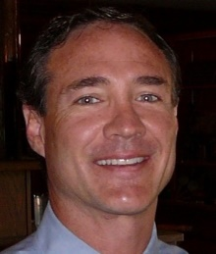  Jim Davis | Go Fresh Homes  and  Omni Home Builders
32045 Castle Court, Suite 100, Evergreen, CO 80439
Creator of investment opportunities in affordable housing across the US. We specialize in mobile homes, modular homes and multifamily properties.

www.gofreshhomes.com |  | jd@gbsc.global | Office: 303-679-6414  Mobile: 303-618-0155

Real Estate Services
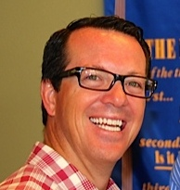  Eric Gill | Bear Paw Stanbro Property Management, Inc.
PO BOX 1394 28265 Highway 74 Evergreen, CO 80437
Bear Paw Stanbro Property Management, Inc. is a full-service management company that handles all aspects of management like-determining rent values, tenant screening (credit/criminal reports) and managing throughout the term of the lease.
http://www.bearpawrentals.com/ |  | Eric@BearPawRentals.com | Office: 303-674-8363 x17  Fax: 303-674-8269

Real Estate Services
Barbara Wingate | RE/MAX Alliance Evergreen
30480 Stagecoach Blvd, Evergreen, CO 80439
Commercial Brokerage Services: Seller /Buyer Representation, Investment Sales /Analysis/
Property Evaluation. I am a caring professional and work with local clients, national clients and international clients as a member of RE/MAX Global network. CCIM, CNE
www.barbarawingate.com |  | barbarawingate@remax.net | Office: 303-670-6368  Fax: 866-670-5040

Mortgage Lending, Mortgage Broker, Real Estate Loans
Chris Davis | Unibell Financial, Inc.
550 S. Wadsworth Blvd., Suite 301, Lakewood, CO 80226
Real estate loans, residential and commercial, mortgages for purchase, refinance, investment property, multi-unit dwellings, Conventional, Jumbo, VA, FHA, home equity lines, Reverse Mortgages for seniors, down payment assistance grants, first-time homebuyers.
www.UnibellFinancial.com |  |  | chris@unibellfinancial.com |  | Office 303-502-0422  Fax 303-830-2290
Senior Services
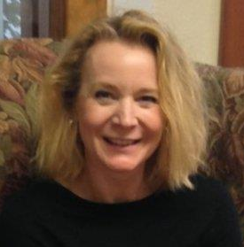  Nancy Tzeng |  | Seniors’ Resource Center
5120 Hwy. 73, Evergreen, CO 80439
We are dedicated to enhancing the independence, dignity and quality of life for seniors in our communities. At Seniors’ Resource Center we provide an array of services that enable older adults to remain in their homes and thrive, such as transportation, in home care, adult daytime programs, life enriching activities and support for both older adults and their caregivers.
www.SRCaging.org |  |  |  | ntzeng@srcaging.org |  | 720-236-1184  303-674-2843

Training
Alan Rubin | TableForce
28825 Summit Ranch Dr. Golden, CO 80401
TableForce offers your organization negotiation skills training for both those members of your team on the purchasing side and on the sales side. This will allow your organization to increase margins, focus your customers on value you can provide them, and speed both purchasing and sales cycles.
www.tableforce.com |  | alan@tableforce.com | 303-725-8750

Travel
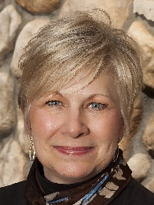  Susan Hammond | Endless Travel
28265 Hwy 74, Unit A, Evergreen, CO
Full service travel agency located in downtown Evergreen. We specialize in small group travel and assisting our clients plan fabulous vacations.

www.endlesstravel.net |  | susan@endlesstravel.net | 303-674-6616

Travel
Linda Lovin | Travel Advisor  Endless Travel
28265 Highway 74, Evergreen, Colorado 80439
As an independent contractor travel advisor with Endless Travel, I have the privilege of helping clients plan their next vacation.
www.endlesstravel.net |  | linda@endlesstravel.net | 303-674-6616 (O)  720-244-3101(C)

