Evergreen Colorado Rotary Visits the Glove Cities Rotary Club
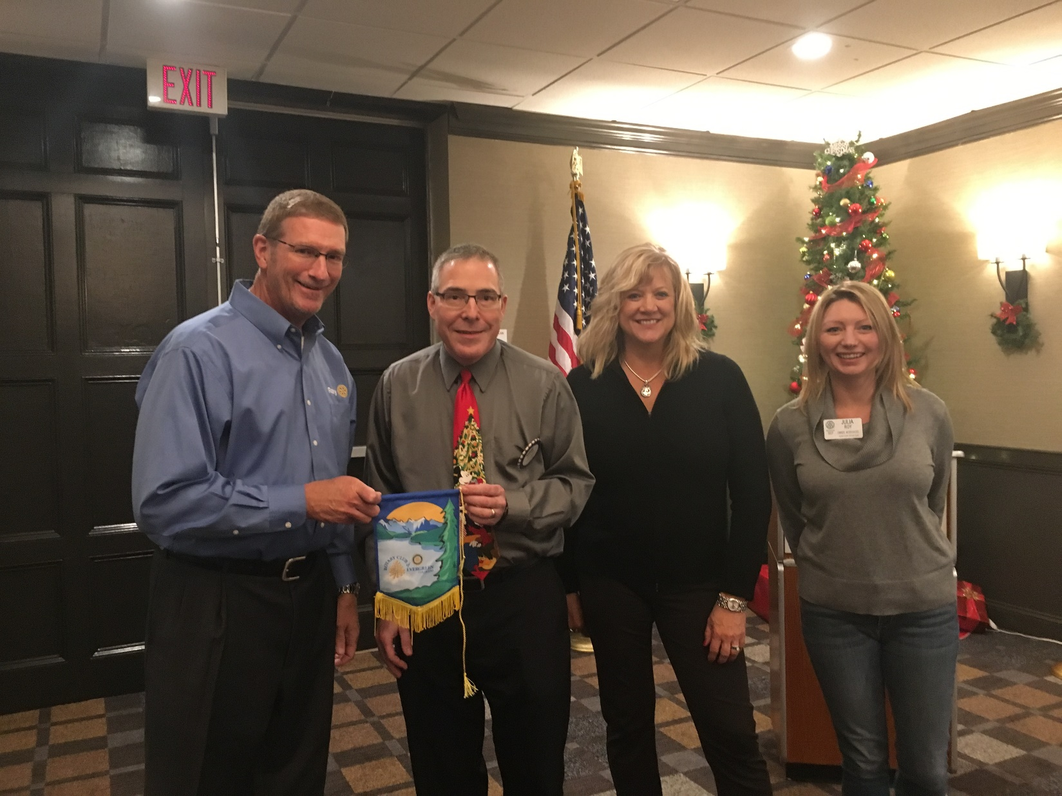Glove Cities Rotary had 2 visitors from Colorado this week at their December 5th meeting! Tim & Kathleen Eagan, former residents of Gloversville, stopped in to our meeting while visiting family in the area.
The Eagans are very active in their club, Rotary of Evergreen Colorado, and they has an exciting project to share with us!
Due to lack of services as they live in an unincorporated township they have had to see the desecration of the landscape as people just dump recyclables in the beautiful natural setting of their town. Being Rotarians, they decided to get their club involved and do something about it!
They have created an annual Event called Recycle Round Up where people can bring their recycles to them and they have them hauled away to be recycled or refurbished. This year at the September 23rd event they took in: 12,400 lbs. of shredded paper, 53 bicycles for Trips For Kids, 6 pairs crutches for Crutches 4 Africa, 24,500 pounds of TVs Electronics for Goodwill, 2 1/2 tons of metals, 122 pounds of clothes, 24 cubic yards of Styrofoam, 86 tires, 6 car seats (which are apparently no good after 5 years!)
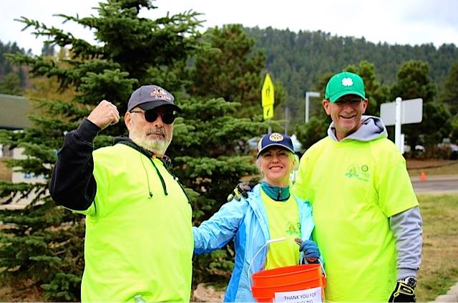According to recycling-revolution.com, making recycled raw materials takes less energy than processing the original raw materials: Making recycled aluminum saves 95 percent of the energy usually used to make aluminum from raw materials, Recycled steel uses 60 percent less energy, Recycled newspaper uses 40 percent less energy, Recycled plastics use 70 percent less energy, Recycled glass uses 40 percent less energy.
Every ton of paper made from recycled materials saves 17 trees, about 450 gallons of oil and about seven gallons of water. Every ton of plastic that is recycled saves the equivalent energy of 1,000 to 2,000 of gasoline. 7 million tons of metals recycled reduced greenhouse gas emissions at equivalent of removing 5 million cars from road for one year.

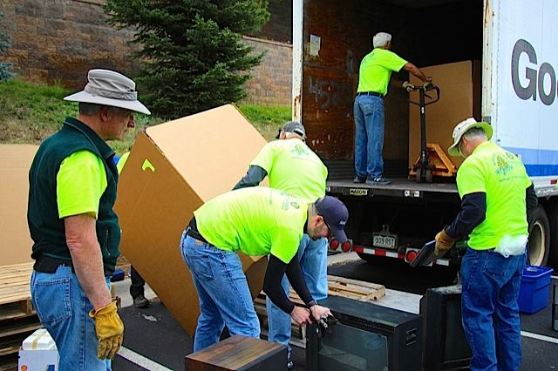Manufacturing products from recycled materials often generate less air and water pollution than what would have been generated when the product was made from the original materials. For example, making recycled paper creates 74 percent less air pollution and 35 percent less water pollution than making paper directly from trees.
This amazing event has brought the community together and done a real service for the environment in their area, and they would love to share how they do it with you if you would like to create a similar event for your area! They can be reached through their web site www.evergreenrotary.org or through their Facebook page @evergreenrotaryclub.

