http://yourhub.denverpost.com/blog/2018/06/evergreen-rotary-club-president-donates-6000-to-evergreen-chorale/218268/

Evergreen Rotary Club President donates $6,000 to Evergreen Chorale
Posted by rotary on June 14, 2018 in Evergreen, Evergreen Business, Evergreen Education, Evergreen Government, Jefferson County | 12 Views | Leave a response
The Rotary Club of Evergreen has a long tradition of allowing the outgoing president to make personally designated grants to nonprofit organizations of their choice. It’s the club’s way of saying thanks for leading the organization this past year.
Larry Caine, president of Evergreen’s Rotary Club during the 2017-2018 year, made his presentation of $6,000 to the Evergreen Chorale. Caine said, “This gift is in recognition of the heightened level of excellence the Evergreen Chorale has achieved under the artistic direction of Christine Gaudreau and the business direction of Susan Kramer in these past six or seven years.”
Caine further explained that while many outgoing presidents have spread around their allotted grant money, he focused the entire amount entrusted to him on the Evergreen Chorale as recognition of the tremendous growth the organization has achieved, most notably through the winning of many awards throughout the state of Colorado.
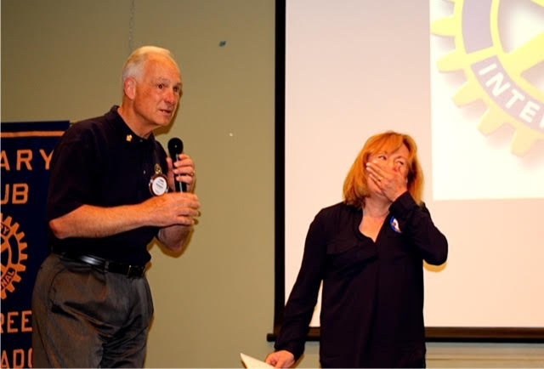
Surprise! Christine Gaudreau finds out Evergreen Rotary’s President, Larry
about the $6,000 grant. Caine with Evergreen Chorale’s
Christine Gaudreau, following the announcement.

Posted in Evergreen, Evergreen Business, Evergreen Education, Evergreen Government, Jefferson County | Tagged Evergreen Chorale, Rotary Club of Evergreen

